Media Literacy Analysis

Introduction
Media Literacy involves applying critical thinking to media messages and using media to create your own messages, which is a necessary 21st century skill. Because everyone interprets media through the lens of their own experience, media literacy analysis requires the examination of points of view, as well as the establishing facts. The following questions are starting points for this type of analysis.

Instructions
- Go to biknotes.com > Resources > Videos and choose a documentary (or choose from the internet).
  - Topic of the documentary must be related to the social sciences.
  - Documentary must be at least 50 minutes long.
  - Documentary must be able to be accessed free on the internet.
- Request approval from the teacher for the documentary you have chosen.
- Title the assignment “Media Literacy Analysis”.
- Follow the directions below when citing the documentary and answering the questions.
Cite the documentary you have chosen at the top of your paper using MLA format:
Video and audio sources need to be documented using the same basic guidelines for citing print sources in MLA style. Include as much descriptive information as necessary to help readers understand the type and nature of the source you are citing. List documentary films by their title. Include the name of the director, the film studio or distributor, and the release year. If relevant, list performer names after the director's name. See example below:
Title of Documentary. Director, Actor(s), Film studio/Distributor, Release year, URL.
Breaking the Silence: Truth and Lies in the War on Terror. Directed by Steve Connelly, and John Pilger,
performance by John Pilger, Carlton Television, 2003, https://vimeo.com/17632795.

In complete sentences, answer all of the following questions on a Word document using these formatting parameters: 1.5 to 2 pages (line spacing 1.15), Times New Roman 12 point font, and 0.5 inch margins (include the questions on your completed document):

AUTHORSHIP

What do I need to know about the filmmaker(s) to analyze the film?

PURPOSE

What central questions is the film trying to answer?
What does the filmmaker want people to know or remember? Who is the target audience?

IMPACT
Who might benefit from the messages in the film? Who might be harmed or disadvantaged by the messages in the film? What have you learned from the film? Why does the film’s message(s) matter to you?
RESPONSE
What kinds of actions might you take in response to the film?
CONTENT
What is the film about (and what makes you think that)? What ideas, values, and information are overt? What ideas, values, and information are implied? Who are the voices of authority in this film? Are there voices left out of the film that would add important perspectives?
TECHNIQUES
What techniques does the filmmaker use to communicate essential ideas? How do those techniques communicate the intended message(s)?
INTERPRETATIONS
How might others see the film in a way that differs from the way you see it? How and why might different types of people interpret the film in divergent ways? What is your reaction to the film and what does it add to your understanding of who you are?
CONTEXT
Since the film was made, has anything occurred that is relevant to the claims or focus of the film?
CREDIBILITY
Which of the film’s assertions are facts and which are opinions? What sources does the film rely on for its information, ideas or assertions? Are those sources credible? What makes you think the sources are credible?
IMPRESSIONS
What else do you want to know about the topic of the film?

On a separate 8.5 x 11 inch piece of paper, create a visual representation of the key idea(s) that the film is trying to communicate. Use color and creativity. It must be drawn by your own hand (no digital graphics).
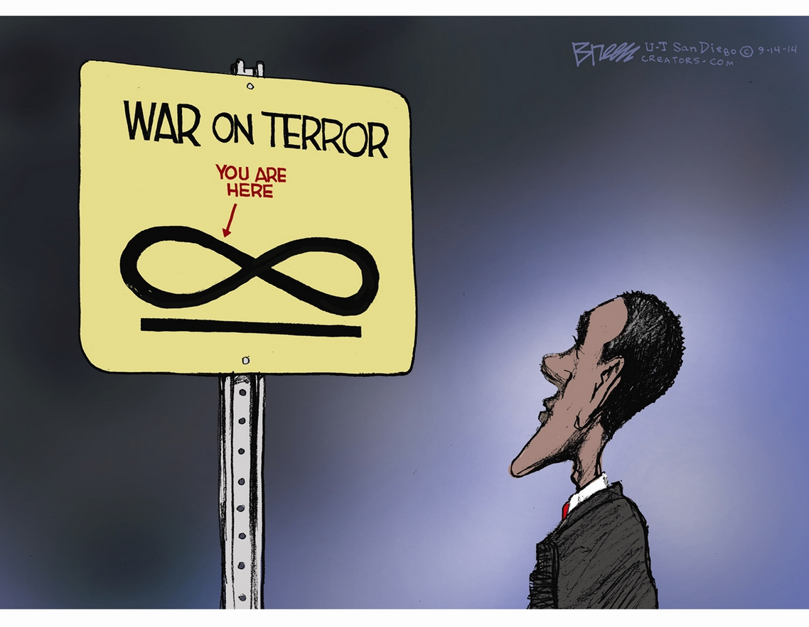

NOTE: The documentary you choose must be approved before you begin this assignment.

